BeeNetZero.com
Stakeholder toolkit
Bee Net Zero is an online platform designed to signpost businesses to advice, support and funding to make the transition to net zero. The site offers practical tips to help businesses start their net zero journey and seek tailored support to meet their specific needs.
BeeNetZero.com is a collaborative offer established by GM Local Enterprise Partnership and delivered by the Growth Company in alliance with leaders, networks and organisations from across Greater Manchester, and beyond, to establish GM as the easiest place in the UK to be a zero carbon business.

Social media
The below posts can be used to promote the event on your accounts across Twitter, LinkedIn and Facebook.
Please include our hashtag in all your posts. It will help us to track social media activity and the spread the word further. Hashtag: #BeeNetZero

Social media
Post 1
Please use the below image with your post.  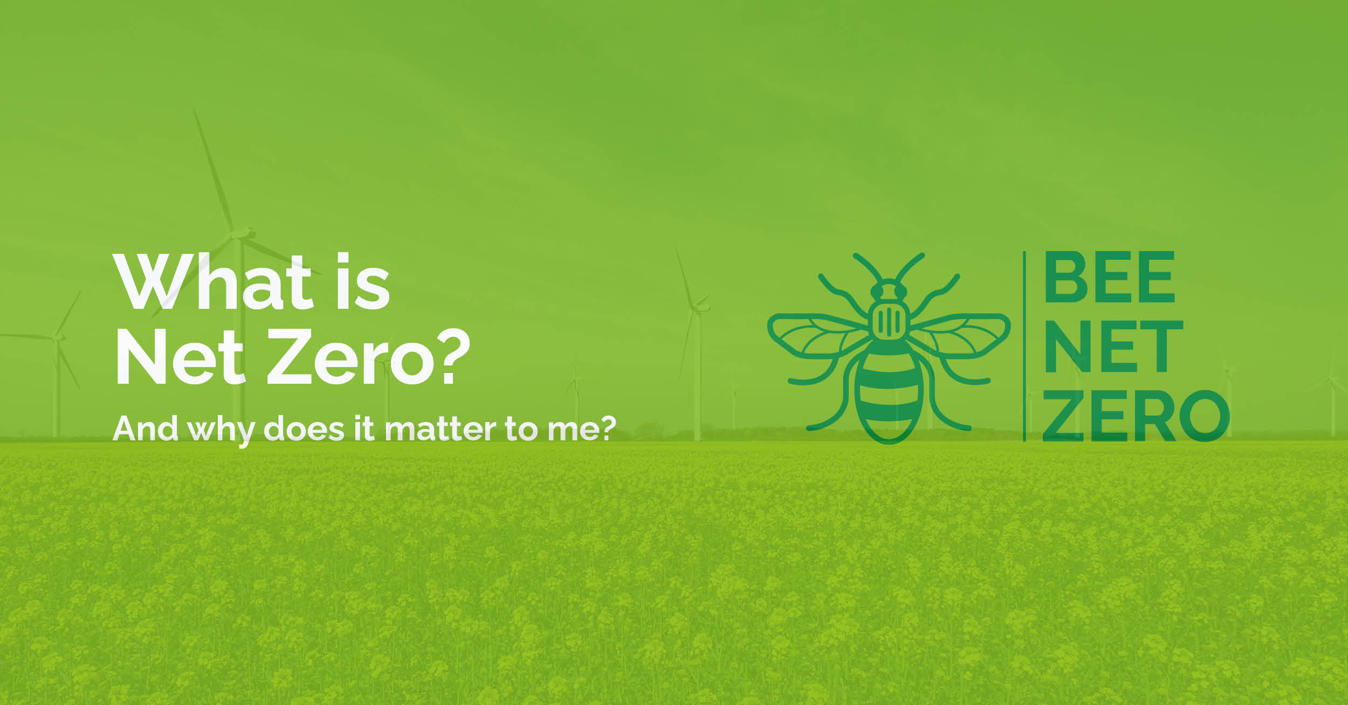 | Businesses showing leadership now will be in a strong position for the future by reducing risk, increasing efficiency and opening the door to new revenue opportunities.  #BeeNetZero #NetZero
Post 2
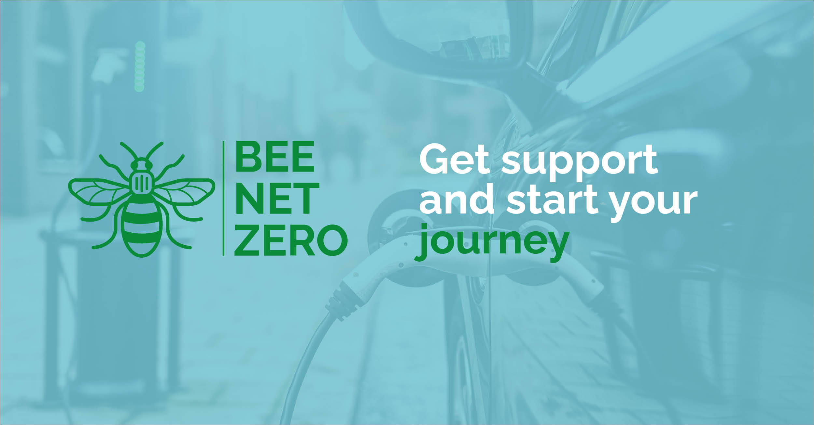 | There is a wealth of support, advice and funding to help you transition to #NetZero.  #BeeNetZero can help you prioritise and find the solution to meet your needs.
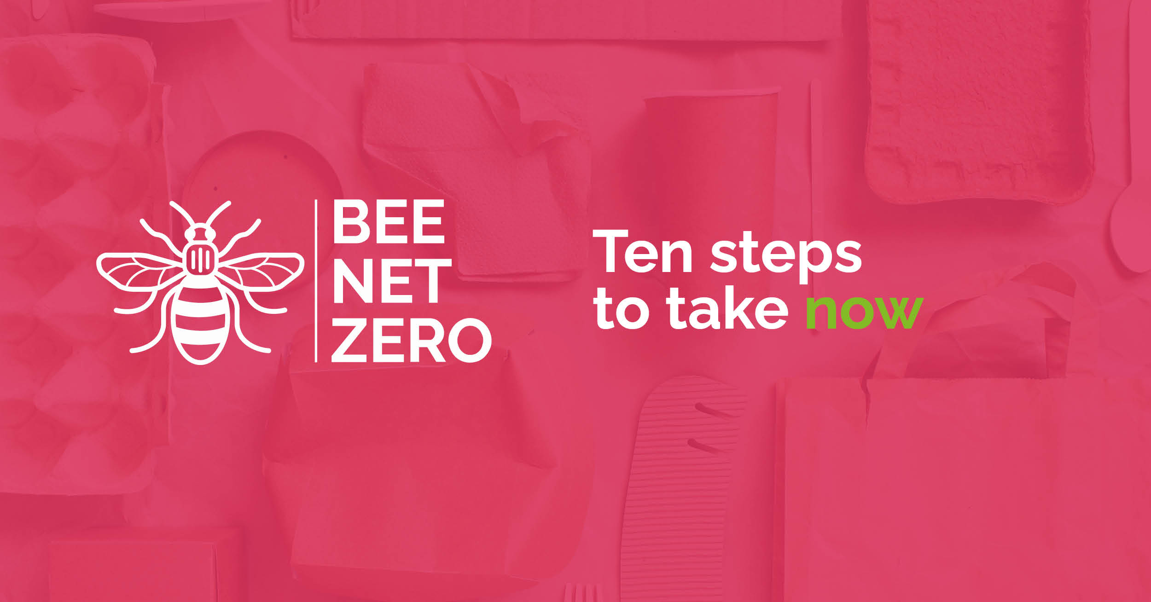 | Identify reduction opportunities and set targets for improvement – just two of ten steps to #NetZero  #BeeNetZero
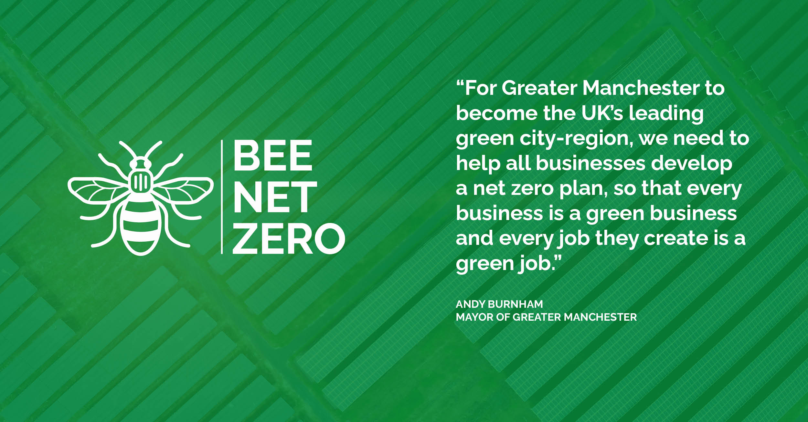 | Bee Net Zero is an alliance between Greater Manchester partners to make our city-region the easiest place to be net zero.  #BeeNetZero #NetZero  Tag: @GMLEP | @greatermcr | @MayorofGM | @bizgrowthhub | @gmchamber | @ElectricityNW | @mcrclimate | @OfficialTfGM | @SMEClimateHub
Get started on your net zero journey today – read our nine immediate actions to kickstart your transition

#BeeNetZero #NetZero

Newsletter copy
Bee Net Zero – making Greater Manchester the easiest place to be a zero carbon business
Greater Manchester’s thousands of businesses are urged to start their own green journey at BeeNetZero.com, a new platform offering publicly-funded support and finance as they take steps towards reducing their carbon emissions.

